DLD LAB Exam

**2-Input OR Gate Implementation:**

IC Name: 74LS32

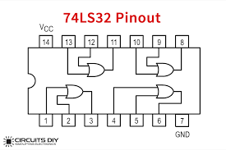

**NOT Gate Implementation:**

IC Name: G-74LS15

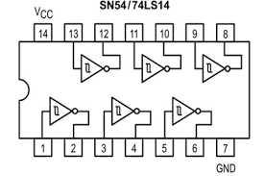

**2-Input NAND Gate Implementation:**

IC Name: -74LS37

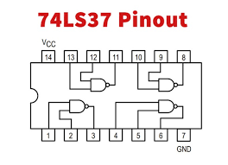

**3-Input NAND Gate:**

IC Name: 74LS10

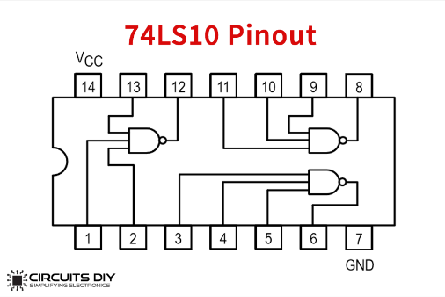

**2-Input NOR Gate:**

IC Name: 74LS02

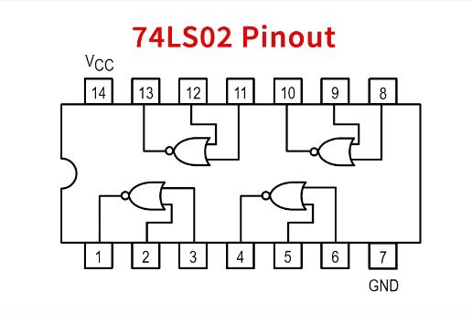

**3-Input NOR Gate Implementation:**

IC Name: 74LS27P

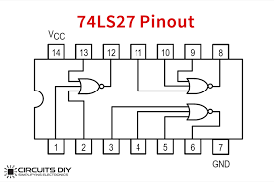

**Full Adder Implementation:**

IC Name: 74LS283

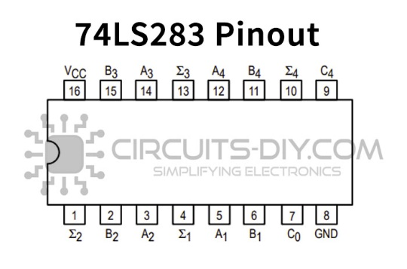

**S-R Latch Implementation:**

IC Name: 74LS279

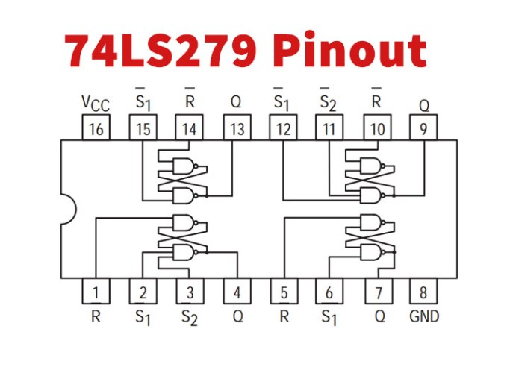

**Wish You Good Luck**